
Year 9

Mini Test 2

Surface Area and Linear

Resources allowed: Calculator and A4 notes page one side

Name: ______________________ Class: ______ Time: 45 minutes Total Marks: 43

- (1,3,3 - 7 marks)
Calculate the area of the following shapes correct to two decimal places

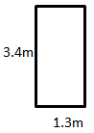
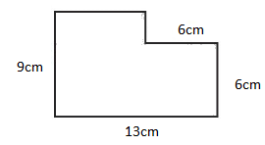

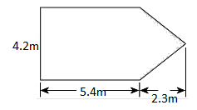

- (2,2,3 - 7 marks)
Calculate the surface area of the following

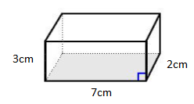

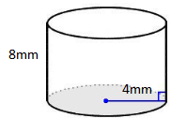

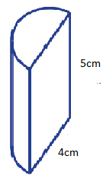

- (2,2 - 4 marks)
Draw the net of the following objects
- Rectangular prism | - Cylinder

- (4 marks)
The outside of an old rectangular jewellery box is being covered in material to make it look like new again. How much material is required to cover the box if the box has dimensions of 10cm, 13cm and 5cm.

- (4 marks)
Write a rule in the form y = mx +c which matches the following table of values
a)
x | -1 | 0 | 1 | 2 | 3
y | -2 | 0 | 2 | 4 | 6

Rule: _____________________________________

b)

x | 0 | 1 | 2 | 3 | 4
y | 2 | -1 | -4 | -7 | -10

Rule: ____________________________________

- (3 marks)
For the graph below, find the gradient and state whether it is positive or negative

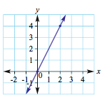

- You need to organise a plumber after a burst pipe has flooded your bedroom. You have been given a quote from the following local plumber, Oscar’s Plumbing. Oscar charges $60 per hour plus a $100 initial start-up fee.

- Complete the table of values for each option and write a rule using “C” for cost and “N” for Number of hours that could be used for each option. (3 marks)

Oscar’s Plumbing
N (number of hours) | 0 | 1 | 2 | 3 | 4 | 5 | 6
C (cost in $)

- Now write a rule you can use to calculate the cost of Oscar’s Plumbing. (3 marks)

____________________________________________________________________

- Create a graph from the table in a) on the graph provided and label each option. (5 marks)

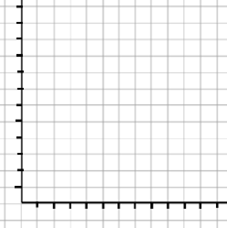

- Find the gradient of this graph and state if it is positive or negative (3 marks)

Extension:

- (4 marks)
A log with a diameter of 80cm is 4m in length. Its hollow centre is 30cm in diameter. Find the surface area of the log in $cm^{2}$, including the ends and the inside correct to 2 decimal places.

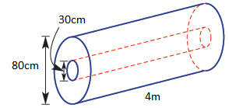

- (6 marks)
A solar powered car travels 120 km in 5 hrs.
- What is the rate of change of distance over time?
- Draw a graph that plots the distance (d) travelled over time (t), using $0≤t≤5$.
- Find the gradient of your graph, and a rule for d
- Use your rule to find:
- The distance after 3.5 hrs.
- The time it takes to travel 80 km.



End Test

